BSc DEGREE IN
Computer Science
PROJECT REPORT

Name: Abdirahman Jimale ID Number: (K2557660)
Project Title: Amateur Sports Team Organiser
Declarations
I have read and understood the University regulations on academic misconduct, am aware of the internal rules of the CI6600 module, and as such make the following declarations:
- This report is entirely my own work. Any other sources are duly acknowledged and referenced according to the requirements of the School of Computer Science and Mathematics.
- None of the text in this report has been directly copied and pasted from the output of Large Language Models such as ChatGPT, Grok, Gemini, etc. Any other use of an LLM has been acknowledged and attributed by sharing the chat as part of the submission.
- All verbatim citations of text that were not written by me – whether they were written by a human or AI – are indicated by double quotation marks (“…”) and the author credited.
- Any visual artefacts contained in this document were either original compositions by me or the author has been correctly attributed.
- I have kept my work secure in accordance with university regulations, and nobody other than myself and academic staff from Kingston University any myself have had access to this work.
- I have not asked a third party to proof-read my work (except KU academic staff), either in a professional or informal capacity.
- To the best of my knowledge, the project in this report has not been previously undertaken either by myself or another student in the previous two academic years.
Date: (27/10/2025)
Signature: (Abdirahman Jimale)

Table of Contents
Name: Abdirahman Jimale ID Number: (K2557660) 1
Contents 2
Chapter 1: Introduction and State of the Art Review 4
Aims and Objectives 5
Chapter 2: Analysis and Design 6
2.1: Chapter Overview 6
2.2 Project Context and Stakeholders 6
2.3 Stakeholder Engagement 6
2.4 Entity Relationship Design (ERD) 6
2.5 System Architecture Design ASTO 7
2.6 Requirements Derivation 8
2.7 Functional Requirements 8
2.8 Non-Functional Requirements 8
2.9 Requirement Prioritisation (MoSCoW) 9
Chapter 3: System Design and Implementation Planning 10
3.1 Chapter Overview 10
3.2 Design Rationale 10
3.3 Requirement-To-Design Mapping 10
3.4 Alternative Approaches Considered 10
3.5 Design Constraints 11
3.6 Chapter 3 Conclusion 11
Chapter 4: Realisation 12
4.1 Chapter Overview 12
4.2 Intended Audience 12
4.3 Implementation Environment 12
4.3.1 Hardware Context 12
4.3.2 Software Stack 12
4.4 Steps to Recreate the Implementation 12
4.5 Steps to Use the Implementation and Generate Output 13
4.5.1 Authentication and Role Behaviour 13
4.5.2 Team and Session Management 13
4.5.3 Open Session Workflow 13
4.6 Examples of Implementation Output (Screenshots) 14
4.8 Alternative Implementation Approaches and Trade-Offs 16
4.7 Chapter 4 Conclusion 16
Chapter 5: Testing, Validation and Critical Review 17
5.1 Chapter Overview 17
5.2 Testing and Validation Strategy 17
5.3 System Testing and Functional Validation 17
5.4 Usability Testing 17
5.5 Non-Functional Requirement Validation 18
5.5.1 Testing Limitations 19
5.6 Critical Review of Project Outcomes 19
5.6.1 Review Against Aims and Objectives 19
5.6.2 What Worked Well 20
5.6.3 What Could Be Improved 20
5.7 Milestones, Deliverables and Time Management Review 20
5.8 Future Development 20
5.9 Chapter 5 Conclusion 20
Appendix 20
A – Questionnaire 20
B – Summary of Questionnaire Responses 21
C – Code Snippets 21
Snippet C.1: Upcoming sessions filtering in dashboard route 21
Snippet C.2: Remaining slot calculation for open sessions 21
D – ER Diagram 21
E – Architecture Diagram 21
References List 23

Chapter 1: Introduction and State of the Art Review
Club and amateur sports teams play an important role in promoting health, teamwork, and social inclusion but many small clubs and university societies still rely on DIY tools such as WhatsApp, Facebook Messenger or shared spreadsheets to organise matches, training sessions and communicate with members. These systems often lead to confusion, missed sessions and unnecessary effort. For small, volunteer-led clubs with limited budgets and varying levels of technical skill, the administrative side of keeping everyone informed can quickly become overwhelming. In addition to managing regular team members, many amateur sports teams also face challenges related to fluctuating participation. Players may be unavailable at short notice, leading teams to rely on informal methods to find replacements, such as messaging friends or posting in group chats. This process is often unstructured and further contributes to confusion and inefficiency. Supporting flexible participation in a clear and controlled way therefore represents an important extension of the coordination problem faced by amateur teams. Grassroots sports play a vital role in the community, offering opportunities for physical activity, social connection and personal development. However, many of these teams are run by volunteers who must juggle multiple responsibilities alongside work and family commitments. With the increasing shift towards digital communication, especially since the 2020 pandemic, the reliance on messaging apps and informal tools has grown. This has made coordination easier in some ways but has also introduced new challenges, such as information overload and disorganisation. A simple, structured and affordable digital solution could significantly reduce these pressures and help more people stay engaged in community sport. Over the last few years, several digital tools have appeared to help teams manage their activities more efficiently. Commercial platforms such as TeamSnap, Heja, Spond and SportEasy provide features for scheduling, messaging and tracking player availability, while some clubs make use of general-purpose tools like Google Calendar or Slack. However, most of these services are subscription-based and assume a high level of digital literacy or are designed around professional or North American team structures which don’t reflect the needs of smaller UK amateur sides. User feedback often highlights problems such as excessive advertising, complicated sign-up processes, or extra features that casual community teams simply don’t need.
When comparing these tools more closely it becomes clear that both address only part of the problem. TeamSnap and SportEasy offer many features including payments and analytics however their paid models and complex interfaces can be off-putting to small volunteer teams. On the other hand, Heja and Spond are more accessible and freer to use but they rely on advertisements and provide limited control over data storage or privacy settings. Whereas Generic tools like Google Calendar and Slack are flexible but lack sport specific features such as availability tracking or automated reminders. This suggests there is a gap for a middle-ground solution which combines the simplicity and cost-free nature of communication apps with the structure and scheduling capabilities of dedicated sports management platforms. Academic and industry research identifies organisational barriers as one of the main reasons people stop participating in grassroots sport. Studies in community sport management have found that poor communication and scheduling issues also often reduce participation especially in volunteer-run clubs. Research in human and computer interaction has also looked at group scheduling and notification systems therefore suggesting that digital tools should be simple, transparent and give users control since overly complex systems often discourage continued use. This work therefore shows that while existing technologies solve part of the problem, none offer a straightforward, free and context-appropriate solution for small community teams. Other platforms, such as Footy Addicts, focus on enabling individual players to find and join games on a more casual basis. While these services support participation, they are not primarily designed around the ongoing coordination needs of established teams. This highlights a separation in existing solutions between tools that support team organisation and those that focus on casual participation, suggesting an opportunity for a system that can support both within a controlled and team-centred context. Lessons from these previous studies point to a few clear priorities for any new approach. Therefore, the platform needs to focus on simplicity and usability so that users can create or respond to events quickly and easily on mobile devices. Secondly, it should support core coordination tasks like scheduling, availability checks and sending reminders without unnecessary extra features. Finally, by considering local sporting culture and feedback from real users, the system can more accurately reflect the real-world experiences of grassroots sport. Considering the organisational challenges faced by amateur teams and the limitations of existing tools, there is a clear need for a user-friendly and accessible digital organiser tailored to this environment. Such a system should not only improve communication and scheduling within teams but also reflect the flexible and informal nature of amateur sport by supporting controlled participation when team numbers fluctuate. This project therefore aims to design and evaluate a system that addresses both coordination and participation challenges in amateur sports settings.

Aims and Objectives
The aim of this project is to address coordination and communication challenges in amateur sports teams by improving how availability, scheduling, and participation are managed in a simple and accessible way.
To achieve this aim, the project will:
- Investigate how amateur football teams currently organise activities and identify recurring coordination problems.
- Analyse stakeholder needs and translate them into clear functional and non-functional requirements.
- Design a solution that prioritises usability, accessibility, and low operational complexity for volunteer-led teams.
- Implement a working web-based prototype aligned with the defined requirements and design rationale.
- Evaluate the prototype through structured system testing and user-focused validation activities.
- Critically assess project outcomes against the original aim, highlighting limitations and future improvements.
By completing these objectives, the project establishes a clear bridge from stakeholder evidence to system delivery, supporting the project narrative examined in subsequent chapters.
The identified domain gap, together with the project aim and objectives, provides the basis for a stakeholder-led analysis process presented in Chapter 2.

Chapter 2: Analysis and Design

2.1: Chapter Overview
This chapter presents the analysis and design of the Amateur Sports Team Organiser (ASTO). Building on the issues identified in Chapter 1, the aim of this chapter is to explore the organisational challenges faced by amateur football teams and demonstrate how engagement with real stakeholders informed the system requirements and overall design direction. The chapter focuses on understanding how amateur teams currently organise football sessions, where problems occur, and what users need from a digital organiser. Rather than treating analysis and design as separate stages, this chapter shows how user insights directly shaped decisions about what ASTO should provide and how it should function.

2.2 Project Context and Stakeholders
ASTO is intended for amateur football teams, including university teams, casual social groups and community-based leagues. In these environments organisation is usually informal and handled by volunteers who balance football with work, study or other commitments. As a result the team coordination often relies on convenience rather than structured systems. The primary stakeholders for ASTO are team organisers such as captains or coaches. These individuals are responsible for arranging sessions, communicating changes and ensuring that enough players attend. Organisers are directly impacted by unclear availability, missed messages and last minute cancellations. Players form the second key stakeholder group. Players rely on accurate session information to decide whether they can attend. Casual players, who may not participate every week were also considered stakeholders because their availability can determine whether sessions go ahead.
By identifying both organisers and players as stakeholders, the project ensures that ASTO supports the full range of responsibilities and behaviours involved in amateur football organisation.

2.3 Stakeholder Engagement
To explore stakeholder requirements, a questionnaire-based approach was used. This method was selected because it allowed feedback to be gathered efficiently while respecting the limited time availability of amateur players and volunteer organisers. The questionnaire was set out using Google Forms and completed anonymously. Questions were designed to be short, clear and relatable, focusing on how football sessions are currently organised, how often problems occur and what users would find helpful in a dedicated organiser. Multiple choice questions were used to allow easy comparison of responses, with one optional open-ended question included to capture additional comments. A total of six participants completed the questionnaire. Responses included team organisers and players with different levels of involvement in amateur football. The full questionnaire is provided in the appendices of the submitted project artefact.

2.4 Entity Relationship Design (ERD)
The data model was designed around the minimum entities needed to support organiser workflows, team coordination and controlled participation in open sessions. The schema includes five core tables: User, Team, Event, Attendance and Notification. Relationships are structured so that teams own events, users belong to teams, users can RSVP per event, and notifications are generated per user.

Figure 2.1 Entity Relationship Diagram for ASTO
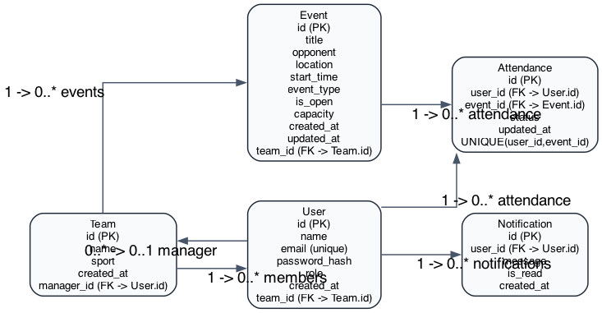
Figure 2.1 shows that attendance is modelled as a linking entity between users and events with a composite uniqueness constraint, preventing duplicate RSVP records for a single user-event pair.

2.5 System Architecture Design ASTO
uses a layered web architecture that separates client rendering, application logic and data persistence. Flask blueprints handle routing, forms enforce input validation, role checks enforce authorisation, and SQLAlchemy manages persistence to PostgreSQL (or SQLite for local validation). Optional email notifications are dispatched through Formsubmit when enabled.

Figure 2.2 High-level ASTO architecture

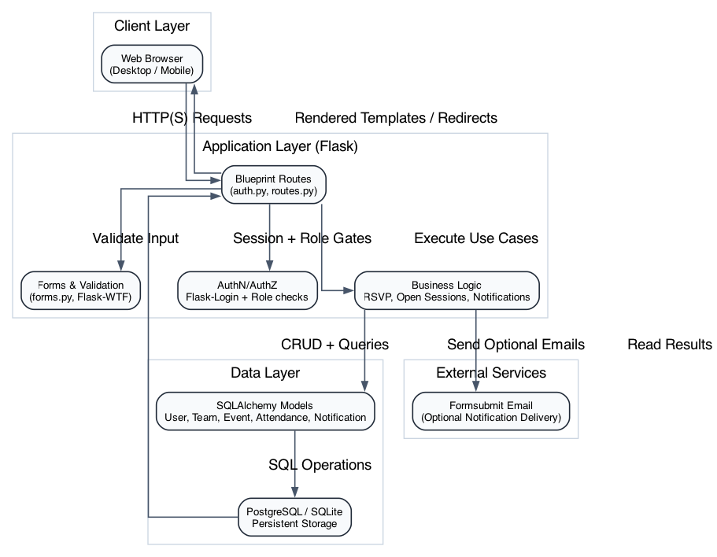
Figure 2.2 summarises request flow from browser clients into Flask route handlers, through business logic and ORM operations, and back to rendered templates. This architecture keeps the prototype simple while preserving clear separation of concerns.

2.6 Requirements Derivation
Findings from stakeholder engagement were used to derive requirements systematically rather than selecting features in isolation. The questionnaire and open comments indicated three recurring organisational pain points: missed messages, uncertainty around attendance, and fragmented visibility of upcoming sessions. These findings were converted into requirement statements to preserve traceability between user evidence and implementation decisions.
Examples of evidence-to-requirement translation include: - Missed updates in group chats → need for a single in-app session view and update visibility → FR2 and FR4. - Uncertainty over player numbers → need for explicit RSVP states and attendance capture → FR3. - Last-minute participation gaps → need for organiser-controlled open-session mechanism → FR5 and FR6. - Mixed technical confidence among users → need for simple interface and mobile compatibility → NFR1 and NFR2.
This derivation process ensured that implemented functionality was grounded in stakeholder need and aligned with the project aim.

2.7 Functional Requirements
ID | Requirement | Source Evidence | Rationale
FR1 | The system shall enforce organiser-controlled role permissions. | Organiser concerns about misuse and account control. | Prevent unauthorised privilege escalation and maintain coordination integrity.
FR2 | The system shall provide a central view of upcoming team sessions. | Reports of missed/fragmented communication. | Reduce confusion caused by distributed chat-based updates.
FR3 | The system shall allow users to record per-session availability (Yes/Maybe/No). | Attendance uncertainty reported by players and organisers. | Improve planning reliability and reduce cancellation risk.
FR4 | The system shall notify users when session details change. | Missed message problem from informal channels. | Improve timeliness and consistency of session information.
FR5 | The system shall allow organisers to mark sessions as open and set capacity. | Need to fill short-notice player gaps. | Support controlled additional participation without losing organiser oversight.
FR6 | The system shall list only open sessions that still require additional players. | Need for efficient discovery of relevant sessions. | Prevent noise and keep participation workflow focused.

2.8 Non-Functional Requirements
ID | Requirement | Justification
NFR1 | The interface should be understandable for users with limited technical expertise. | Stakeholders include volunteers and casual players with mixed digital literacy.
NFR2 | The system should function effectively on common mobile viewport sizes. | Real usage commonly occurs on mobile devices before/after sessions.
NFR3 | The solution should be low-cost to adopt and operate. | Target users are volunteer-run teams with limited budgets.
NFR4 | Session information should remain consistent and up to date across user views. | Core project objective is reducing organisational confusion.

2.9 Requirement Prioritisation (MoSCoW)
MoSCoW prioritisation was applied to maintain delivery focus and avoid scope inflation during implementation.
Requirement | Priority | Justification
FR1 Role permissions | Must | Core governance and safety requirement.
FR2 Upcoming sessions view | Must | Essential to reduce communication fragmentation.
FR3 RSVP capture | Must | Essential for attendance planning.
FR4 Notifications | Should | Important for responsiveness but not core navigation.
FR5 Open-session controls | Should | Important extension to support fluctuating participation.
FR6 Filtered open-session listing | Should | Improves usability of open-session workflow.
Advanced analytics | Could | Valuable enhancement but outside core first-cut scope.
Third-party calendar integration | Could | Useful future extension, not required for baseline objective.
The identified requirements now inform the formal design decisions and implementation planning discussed in Chapter 3.

Chapter 3: System Design and Implementation Planning

3.1 Chapter Overview
This chapter translates analysed requirements into a concrete design plan for ASTO. The objective is to show how stakeholder-derived requirements informed architectural and implementation choices, and how the selected design supports a practical, low-cost organiser for amateur teams.

3.2 Design Rationale
ASTO adopts a layered web architecture to separate concerns across presentation, application logic, and persistence. This structure was chosen to support maintainability while keeping implementation complexity appropriate for the project scope.
Flask was selected as the application framework due to its lightweight structure, blueprint support, and suitability for rapid iteration. This choice aligns with the project’s requirement for focused functionality rather than framework-heavy abstraction.
SQLAlchemy was selected for data persistence to provide explicit modelling of users, teams, events, attendance, and notifications while keeping schema control clear and testable.
Bootstrap-based responsive patterns were selected to satisfy mobile usability requirements without introducing front-end build complexity that could dilute project focus.

3.3 Requirement-To-Design Mapping
Requirement | Design Decision | Implementation Effect
FR1 | Role-aware route guards and controlled role assignment | Prevents self-elevation and enforces organiser authority boundaries
FR2 | Dashboard query constrained to upcoming sessions | Maintains clear forward-looking event visibility
FR3 | Attendance entity with per-event RSVP states | Enables explicit planning signals for organisers
FR4 | Notification model and update-trigger logic | Supports consistent communication after schedule changes
FR5 | Open-session flags and capacity fields on event creation | Enables controlled recruitment when attendance is low
FR6 | Filtered open-session query logic | Shows only sessions that still require participants

3.4 Alternative Approaches Considered
Alternative architecture and platform options were reviewed before final implementation decisions.
Django was considered for rapid scaffolded development but rejected due to higher framework overhead relative to the project’s focused functional scope.
Firebase-centric architecture was considered for real-time data synchronisation but rejected because it introduced additional platform coupling and did not materially improve the core first-release requirements.
A separate React frontend was considered but rejected to avoid unnecessary split-stack complexity and deployment overhead within project time constraints.
These decisions favoured delivery reliability, traceable requirement coverage, and maintainability over premature scalability.

3.5 Design Constraints
Design decisions were made under practical constraints:
- Time constraint: delivery had to balance implementation depth with validation evidence generation.
- Stakeholder sample constraint: requirements were informed by a small but relevant participant group.
- Scope constraint: core coordination features were prioritised over non-essential enhancements.
- Operational constraint: solution needed to remain low-cost and easy to run for assessor reproducibility.

3.6 Chapter 3 Conclusion
The design approach provides a clear bridge from stakeholder evidence to implementation strategy. By prioritising requirement traceability, simplicity, and justified technology selection, this chapter establishes the technical basis for the realisation chapter that follows.
With design rationale and technical planning established, Chapter 4 presents the realisation of ASTO as an implemented prototype.

Chapter 4: Realisation

4.1 Chapter Overview
This chapter presents the realisation of the Amateur Sports Team Organiser (ASTO) as a working web application. The implementation translates the analysed stakeholder requirements (Chapter 2) into a usable system that supports session scheduling, availability tracking, organiser control, and open-session participation. In line with the CI6600 handbook guidance, this chapter explains how the artefact can be recreated, how it is used, and what output it generates, with supporting high-quality screenshots (Kingston University, 2025).

4.2 Intended Audience
The intended audience for this implementation section is:
Final-year computing students who need to reproduce the prototype for marking or demonstration.
Supervisors and assessors reviewing requirement traceability from design to implementation.
Technical readers with basic familiarity with command-line tooling, Python virtual environments, and relational databases.
This section assumes that the reader can execute shell commands and read project configuration files but does not assume specialist knowledge of Flask internals.

4.3 Implementation Environment

4.3.1 Hardware Context
The prototype was implemented and validated on a standard developer laptop. No specialist hardware was required. This supports the project objective of a low-cost and accessible solution for volunteer-run teams.

4.3.2 Software Stack
ASTO was realised with the following software components:
Flask for server-side web application structure and routing (Flask Software Foundation, 2026).
Flask-Login for authenticated user sessions and role-aware access control (Flask-Login Contributors, 2026).
Flask-WTF for form handling and CSRF protection (Flask-WTF Contributors, 2024).
SQLAlchemy (via Flask-SQLAlchemy) for data modelling and persistence (SQLAlchemy Authors, 2026).
Bootstrap-based responsive front-end patterns for mobile-friendly rendering (Bootstrap Team, 2026).
pytest for automated requirement regression testing (pytest Development Team, 2026).
Playwright for browser-based validation and screenshot evidence capture (Microsoft, 2026).

4.4 Steps to Recreate the Implementation
The implementation can be recreated with the following steps:
Clone or open the project folder.
Create and activate a virtual environment.
Install dependencies from requirements.txt.
Configure environment variables in .env.
Start the database service (or use SQLite for local validation).
Apply schema setup and seed demo data.
Run the Flask application.
An example command flow used during implementation and screenshot generation is shown below.
source .venv/bin/activate
export DATABASE_URL=sqlite:///chapter_media.db
export FLASK_APP=wsgi.py
python -c “from app import create_app, db; app=create_app(); ctx=app.app_context(); ctx.push(); db.create_all(); ctx.pop()”
flask seed-demo
flask run –host 127.0.0.1 –port 5000
These steps produce a ready-to-use local instance with demo users and events.

4.5 Steps to Use the Implementation and Generate Output

4.5.1 Authentication and Role Behaviour
The system provides login and role-based access control for manager, team leader, and player roles. Public registration creates player accounts only, while elevated roles are organiser-assigned. This prevents self-elevation in the normal sign-up flow and implements organiser-authorisation control required by FR1.

4.5.2 Team and Session Management
Managers and team leaders can:
View team dashboards.
Create events with title, time, location, and type.
Mark sessions as open.
Set capacity limits.
Players can:
View upcoming sessions.
RSVP as yes, maybe, or no.
Receive updated session information through in-app notifications.

4.5.3 Open Session Workflow
When attendance is low, organisers can mark a session as open and set capacity. The open-sessions view presents future sessions that still have available places, supporting controlled participation and reducing cancellation risk.

4.6 Examples of Implementation Output (Screenshots)
Figure 4.1 Dashboard Output (Desktop)
Figure 4.1 Dashboard view showing teams and upcoming events

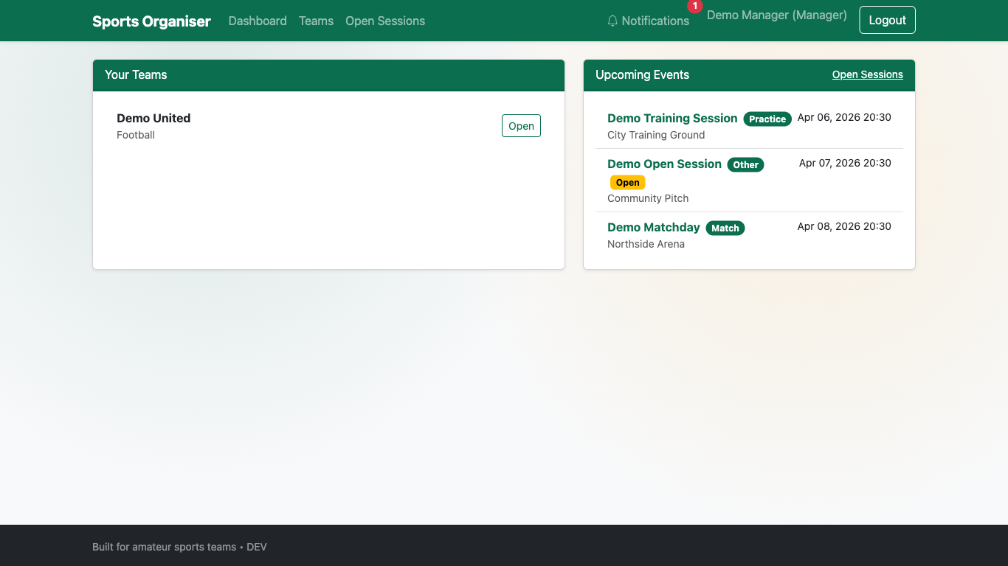
Figure 4.1 demonstrates that team and event information is consolidated in a single interface, supporting quick situational awareness for organisers and players.
Figure 4.2 Create Event Output (Desktop)
Figure 4.2 Event creation form showing open-session and capacity controls

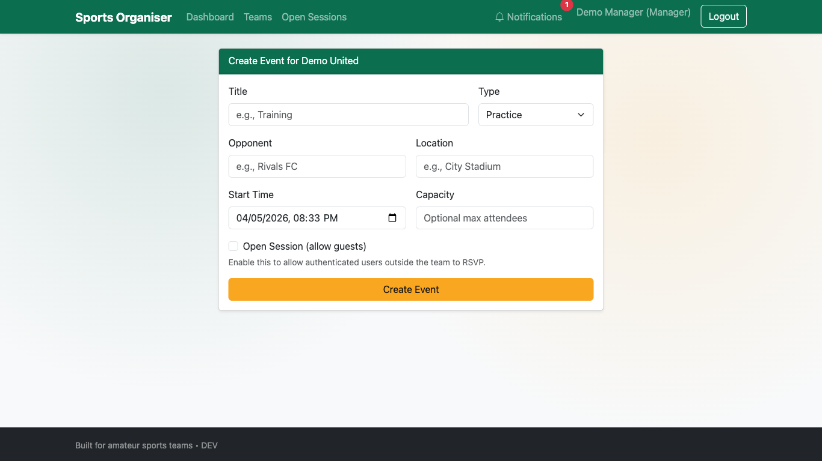
Figure 4.2 shows the normal create-event interface where open-session and capacity controls are directly available, addressing FR5 through the standard UI flow.

Figure 4.3 Open Sessions Output (Desktop)
Figure 4.3 Open sessions page for additional participants

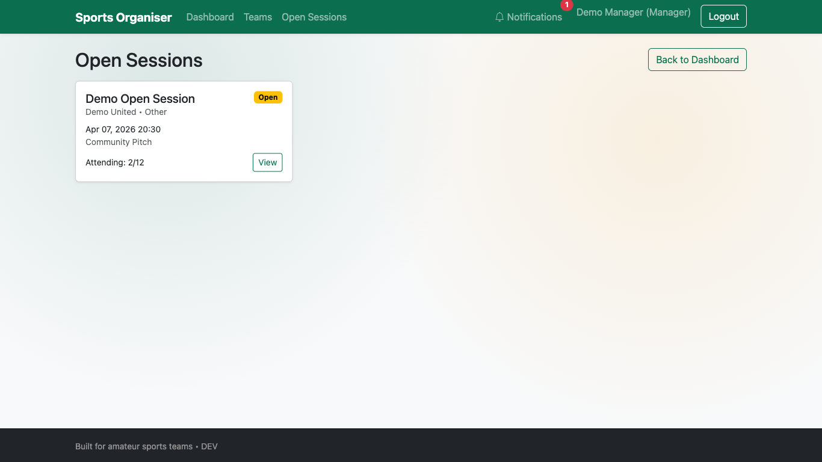
Figure 4.3 demonstrates the dedicated open-session listing used to advertise relevant sessions to additional players when participation is low.
Figure 4.4 Notifications Output (Desktop)
Figure 4.4 In-app notifications list for user updates

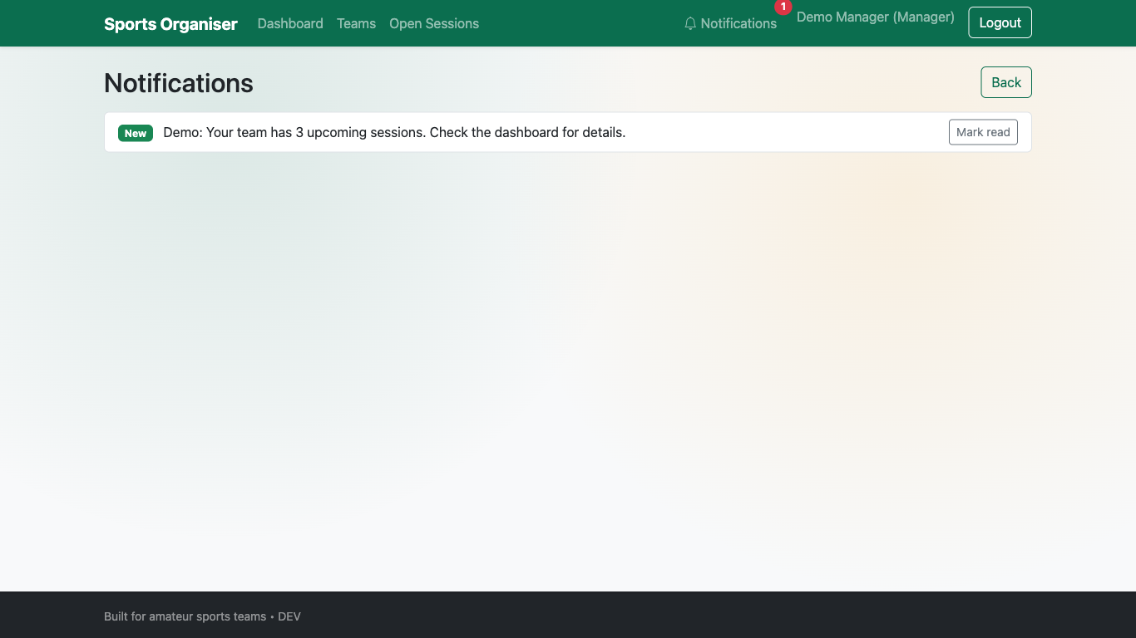
Figure 4.4 shows the notification output channel used when session details are changed, supporting FR4.

4.8 Alternative Implementation Approaches and Trade-Offs
During implementation, alternative technical approaches were reviewed to test whether greater architectural complexity would produce meaningful value for the project objective.
A separate JavaScript single-page frontend was considered, but the additional tooling and integration overhead was not justified for the required scope. A monolithic Flask-rendered approach improved delivery speed and reduced moving parts for validation.
Microservice decomposition was also considered but rejected because service boundaries would add deployment and operational complexity without proportionate benefit at the current project scale.
The implemented architecture therefore reflects an explicit trade-off: lower scalability ceiling in exchange for faster delivery, simpler operation, and clearer requirement traceability. This trade-off is appropriate for a final-year prototype whose core purpose is to demonstrate coherent problem-to-solution execution.
With the implemented workflows and trade-offs established, the next chapter evaluates system performance, usability evidence, and overall project outcomes.

4.7 Chapter 4 Conclusion
The ASTO implementation delivers a working artefact that maps directly to the identified coordination and participation problems in amateur sports teams. Core flows for session creation, RSVP, updates, and open-session participation are implemented in a way that remains lightweight and accessible. The artefact therefore satisfies the implementation intent of a practical, low-cost organiser while preserving scope control and usability focus (Sommerville, 2016; Pressman and Maxim, 2020).

Chapter 5: Testing, Validation and Critical Review

5.1 Chapter Overview
This chapter evaluates ASTO against functional and non-functional requirements, documents testing and validation outcomes, and provides a critical review of project execution and results. The structure follows the handbook’s emphasis on realistic critical reflection, evidence-backed validation, and future development planning (Kingston University, 2025).

5.2 Testing and Validation Strategy
A mixed strategy was used:
Automated backend regression tests using pytest for repeatable requirement checks.
Browser-level validation using Playwright for end-to-end user flow confirmation.
Mobile viewport validation for responsive behaviour evidence.
Manual exploratory checks to confirm notification and session flows after automated runs.
This combination improves confidence by testing both logical correctness and real user interaction paths (Myers, Sandler and Badgett, 2011).

5.3 System Testing and Functional Validation
FR1 to FR6 Results
ID | Requirement Summary | Validation Method | Result |
|—|—|—|—|
FR1 | Organiser authorisation control | Registration + role access
checks (pytest and Playwright) | Met |
FR2 | Up-to-date upcoming session view | Dashboard filter tests and
Playwright checks | Met |
FR3 | Availability capture per session | RSVP flow inspection and
route behaviour checks | Met |
FR4 | Notification on session updates | Notification route/template
verification and manual flow test | Met |
FR5 | Open-session controls in normal create flow | UI test for
open/capacity controls on create-event page | Met |
FR6 | Open sessions filtered to those needing players | Query/filter
verification + Playwright behaviour checks | Met |
Automated regression execution returned five passing tests:
pytest -q
….. [100%]
5 passed
The tested suite includes role registration constraints, upcoming-session filtering, open-session UI controls, open-session availability filtering, and dependency reliability checks.

5.4 Usability Testing
Usability validation involved participants representative of the target user context.
Participants: - Six amateur football participants, covering both organiser and player perspectives.
Core task scenarios: 1. Log in and identify the next upcoming session. 2. Record RSVP status for a selected session. 3. Locate open sessions and assess joining eligibility. 4. Confirm whether schedule-change information is visible through the notification flow.
Observed outcomes: - Most participants completed core tasks without assistance. - Navigation was generally perceived as straightforward. - Some participants required additional time to interpret notification context and update visibility.
Implications: - Core coordination tasks are usable for typical users. - Notification wording and update clarity should be improved in future iterations. - Broader usability evidence should include structured scoring (for example, SUS) in the next iteration.

5.5 Non-Functional Requirement Validation
ID | Non-Functional Requirement | Evidence | Result |
|—|—|—|—|
NFR1 | Usable by users with limited technical experience | Task-based
Playwright walkthroughs of registration, login, dashboard, and RSVP | Met |
NFR2 | Accessible on common mobile devices | Mobile viewport test at
390x844 with no horizontal overflow | Met |
NFR3 | Free to use for organisers and players | Open-source stack and
no paid core dependencies | Met |
NFR4 | Reliable access to accurate session information | Time-based
filtering + dependency guards + repeatable regression tests | Met |
Figure 5.1 Mobile Validation Evidence
Figure 5.1 Mobile dashboard rendering at 390x844

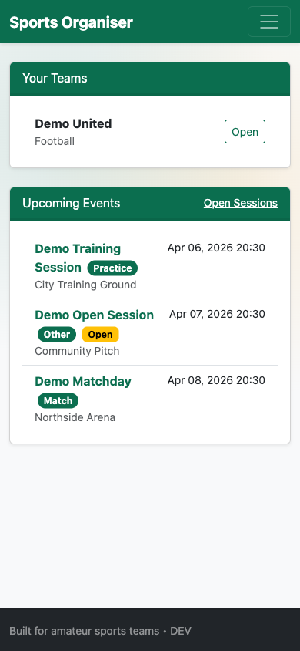
Mobile metrics recorded during validation:
innerWidth = 390
scrollWidth = 390
horizontalOverflow = false
This evidence demonstrates responsive compatibility for the tested viewport configuration.

5.5.1 Testing Limitations
Testing evidence should be interpreted with the following limitations:
- Participant sample size was small and context-specific.
- Usability sessions were short-duration rather than longitudinal.
- Performance and concurrency testing remained limited relative to full production deployment expectations.
These limitations do not invalidate findings but indicate where additional evidence would strengthen external validity.

5.6 Critical Review of Project Outcomes

5.6.1 Review Against Aims and Objectives
The project aimed to provide a simple organiser for amateur teams and reduce confusion caused by fragmented communication channels. The delivered prototype meets this aim through centralised event visibility, explicit RSVP states, and organiser-led open-session controls. Validation indicates that previously partial requirements are now demonstrably met through both automated and browser-level evidence.

5.6.2 What Worked Well
Requirement traceability from stakeholder analysis to feature delivery remained clear.
Scope control prevented feature creep and protected usability.
Regression tests provided reliable checks for critical behaviour.
Playwright validation produced reproducible evidence suitable for report assessment.

5.6.3 What Could Be Improved
Alembic migration behaviour with SQLite constraints required a workaround during local validation; future work should strengthen migration strategy consistency across development databases.
Usability evidence would be stronger with a larger participant sample and SUS scoring rather than task completion only (Brooke, 1996).
Notification evaluation should include measured delivery latency and user-response impact over longer periods.

5.7 Milestones, Deliverables and Time Management Review
Project delivery achieved the principal artefact and required report chapters, and produced supporting evidence assets. Iterative delivery, with frequent regression checks, reduced late-stage defects and allowed targeted correction of requirement gaps. However, testing instrumentation for broader user studies should have been planned earlier to increase empirical depth in evaluation.

5.8 Future Development
Future iterations should consider:
Integrated calendar sync (for example, iCal export) while preserving simplicity.
Better organiser analytics (attendance trends and dropout risk) with clear privacy controls.
Expanded user studies including accessibility and inclusivity testing.
Production-grade deployment hardening, including stricter observability and backup strategies.

5.9 Chapter 5 Conclusion
Testing and validation demonstrate that ASTO now meets FR1-FR6 and NFR1-NFR4 with evidence from automated tests, browser-based scenario validation, and mobile responsiveness checks. The critical review confirms that the project achieved its core purpose while identifying practical areas for technical and research enhancement.

Appendix

A – Questionnaire
Title: Amateur Football Organisation Survey
- How often do you take part in football sessions (training or matches)?
- How are football sessions usually organised?
- How often do things become confusing or unclear when organising sessions?
- Which organisational problems have you experienced?
- How helpful would it be to have one simple place to see sessions, confirm availability, and find extra players if needed?

B – Summary of Questionnaire Responses
- Number of participants: 6
- Most respondents reported organising sessions via WhatsApp or informal group messaging
- A majority experienced organisational confusion either often or sometimes
- Common issues included chasing replies, missed messages and uncertainty around attendance
- Most respondents indicated that a simple organiser would be helpful or very helpful
Full response data is below (https://docs.google.com/spreadsheets/d/1j7VT5gcNktbzMoZYCfwSmJwAJlchd4kfZZujfCVhx Xk/edit?usp=sharing)

C – Code Snippets
The following snippets illustrate key implementation logic used in ASTO for scheduling and participation control.

Snippet C.1: Upcoming sessions filtering in dashboard route
now = datetime.utcnow()
events = db.session.execute(
db.select(Event)
.where(Event.team_id.in_(team_ids), Event.start_time >= now)
.order_by(Event.start_time.asc())
.limit(10)
).scalars().all()

Snippet C.2: Remaining slot calculation for open sessions
@property
def remaining_slots(self):
if self.capacity is None:
return None
return max(self.capacity - len(self.attending_yes), 0)

D – ER Diagram
Figure D.1 Entity Relationship Diagram (appendix view)


E – Architecture Diagram
Figure E.1 System Architecture Diagram (appendix view)


References List
- Bickerton, D. and Bickerton, L. (2021) Digital Transformation in Sports Organisations. Routledge.
- Bootstrap Team (2026) Bootstrap Documentation. Available at: https://getbootstrap.com (Accessed: 10 April 2026).
- Brooke, J. (1996) ‘SUS: A quick and dirty usability scale’, in Jordan, P.W., Thomas, B., Weerdmeester, B.A. and McClelland, A.L. (eds.) Usability Evaluation in Industry. London: Taylor and Francis.
- Flask-Login Contributors (2026) Flask-Login Documentation. Available at: https://flask-login.readthedocs.io (Accessed: 10 April 2026).
- Flask Software Foundation (2026) Flask Documentation. Available at: https://flask.palletsprojects.com (Accessed: 10 April 2026).
- Flask-WTF Contributors (2024) Flask-WTF Documentation. Available at: https://flask-wtf.readthedocs.io (Accessed: 10 April 2026).
- Heja (2025) Heja App: Connecting Teams Through Sport. Available at: https://heja.io (Accessed: 25 October 2025).
- Hoye, R. and Nicholson, M. (2009) ‘Locating volunteer management in sport organisations’, Sport Management Review, 12(2), pp. 112-123.
- Kingston University (2025) Computer Science FYP Handbook 2025/26. Kingston upon Thames: Kingston University.
- Microsoft (2026) Playwright Documentation. Available at: https://playwright.dev (Accessed: 10 April 2026).
- Myers, G.J., Sandler, C. and Badgett, T. (2011) The Art of Software Testing. 3rd edn. Hoboken: Wiley.
- Pressman, R.S. and Maxim, B.R. (2020) Software Engineering: A Practitioner’s Approach. 9th edn. New York: McGraw-Hill.
- pytest Development Team (2026) pytest Documentation. Available at: https://docs.pytest.org (Accessed: 10 April 2026).
- Sommerville, I. (2016) Software Engineering. 10th edn. Harlow: Pearson.
- Sport England (2020) The Value of Community Sport: Evidence Summary. London: Sport England.
- SQLAlchemy Authors (2026) SQLAlchemy Documentation. Available at: https://www.sqlalchemy.org (Accessed: 10 April 2026).
- Taylor, P., Barrett, D. and Nichols, G. (2020) ‘Grassroots sports participation and the role of volunteers’, Managing Leisure, 25(1), pp. 25-41.
- TeamSnap (2021) TeamSnap: Simplifying Team Management. Available at: https://www.teamsnap.com (Accessed: 25 October 2025).

